CST 2309 Lab 13.1 – Maximo Antigua

Complete Lesson 8: Creating Forms with JavaScript

1. Add a screenshot of the js-eleven.html file displayed in the browser as shown in Figure 8-2 on page 2192 after completing Step 5. Include the browser address bar.

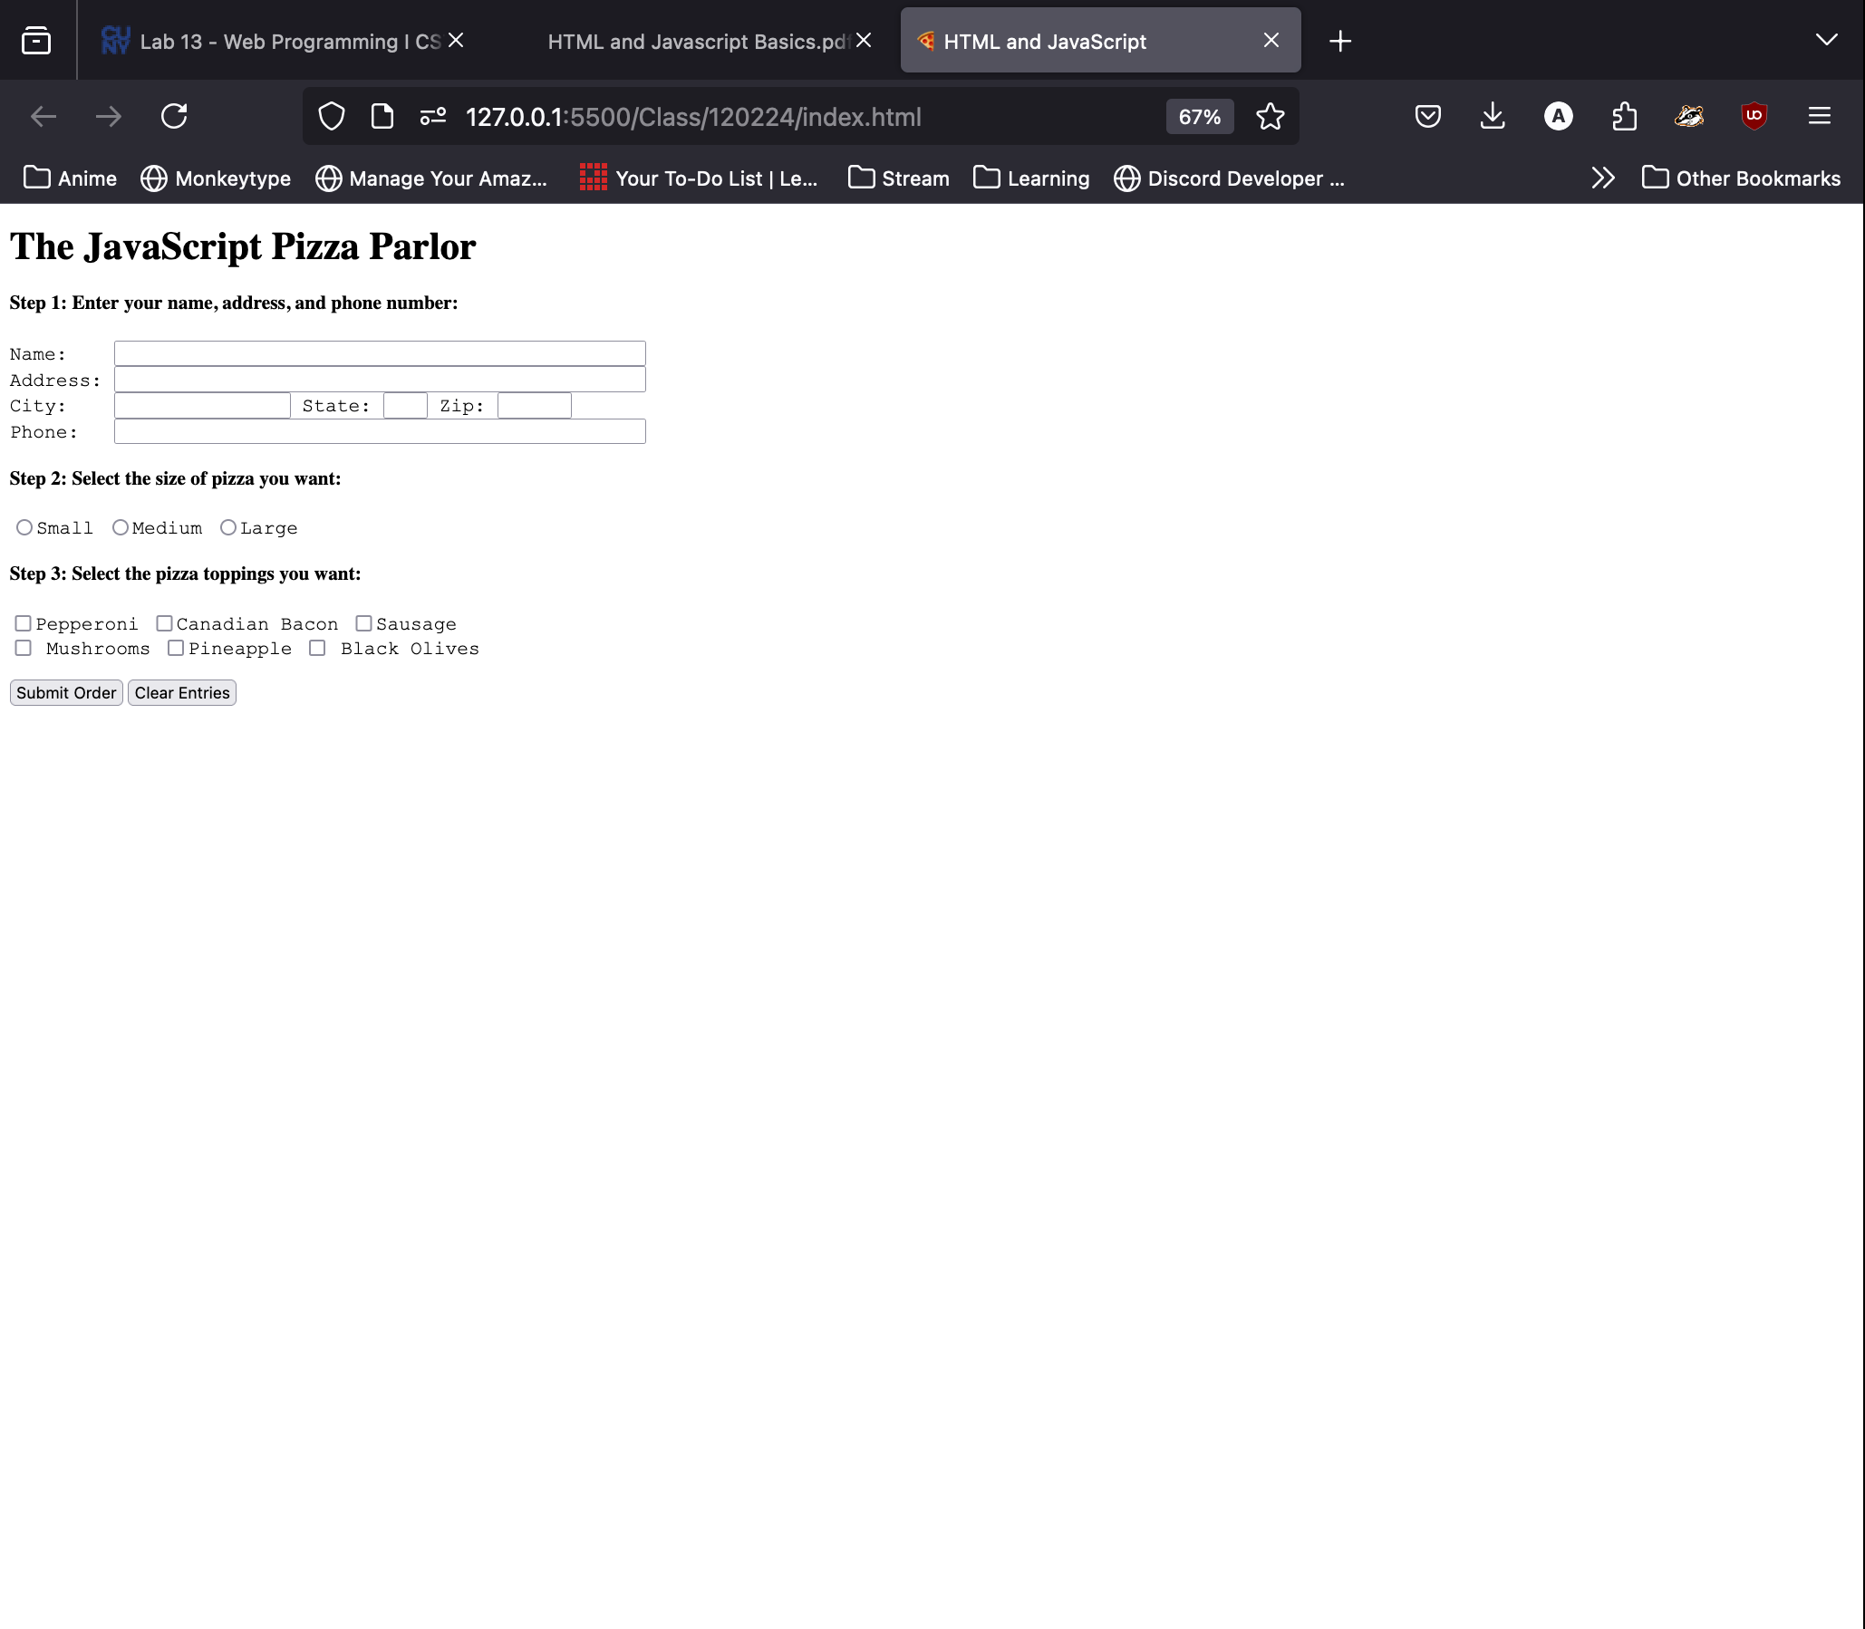

1. Add a screenshot of the js-twelve.html file displayed in the browser as shown in Figure 8-4 on page 192 after completing Step 8. Include the browser address bar.



1. Add a screenshot of the js-forteen.html file displayed in the browser as shown in Figure 8-7 on page 205 after completing Step 8. Include the browser address bar.

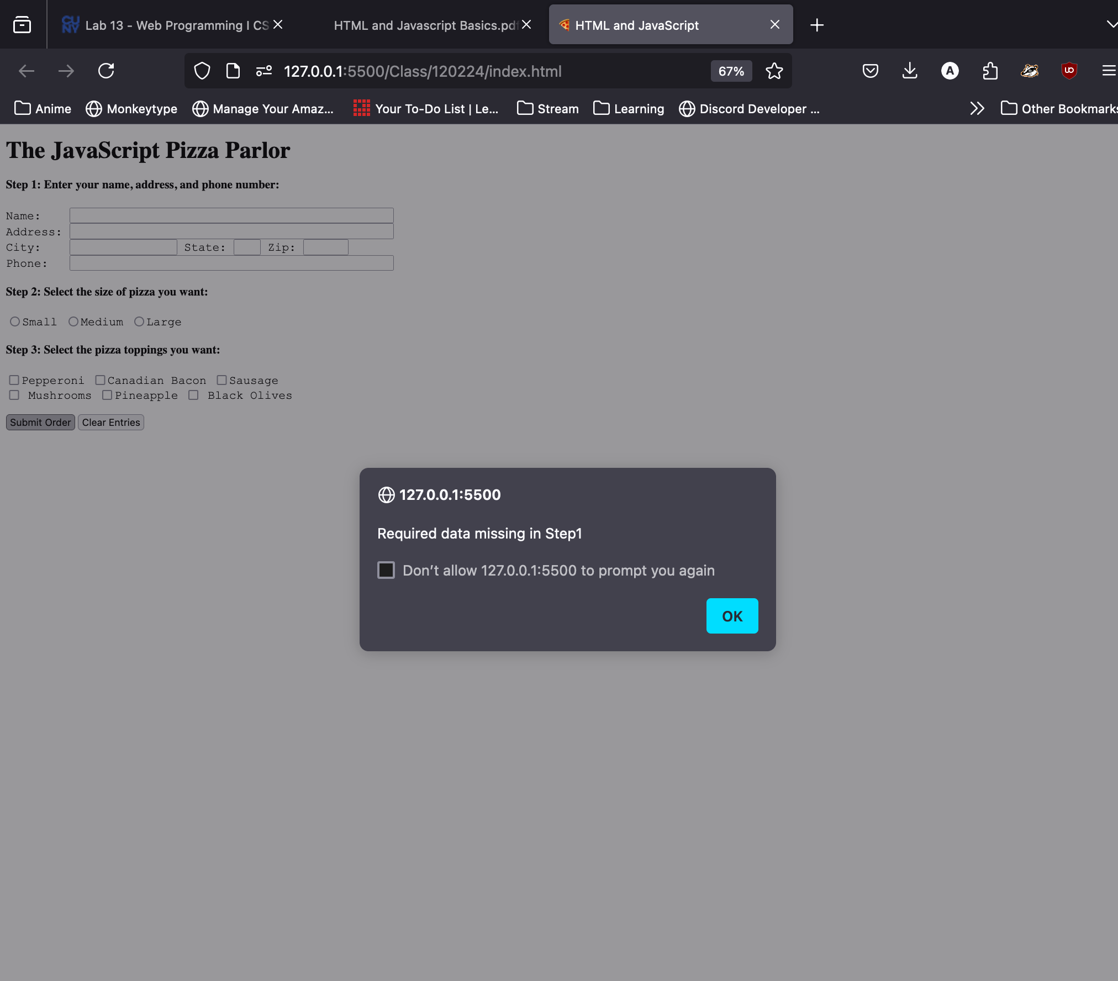

1. Add a screenshot of the js-fifteen.html file displayed in the browser as shown in Figure 8-9 on page 211 after completing Step 9. Include the browser address bar.

